|  |  |  |  |
| --- | --- | --- | --- |
| **F:\Learning bugs\Foundation Subjects\Dolly the Fly - Science.jpgLyng Primary School Knowledge Organiser** | | | |
| **Topic:** | **Science**  **Electricity** | Year 6 | Spring 2 |

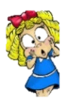

**What should I already know?**

Building on their work in year 4, pupils should construct simple series circuits, to help them to answer questions about what happens when they try different components, for example, switches, bulbs, buzzers and motors. They should learn how to represent a simple circuit in a diagram using recognised symbols.

**Notable scientists**

Thomas Edison

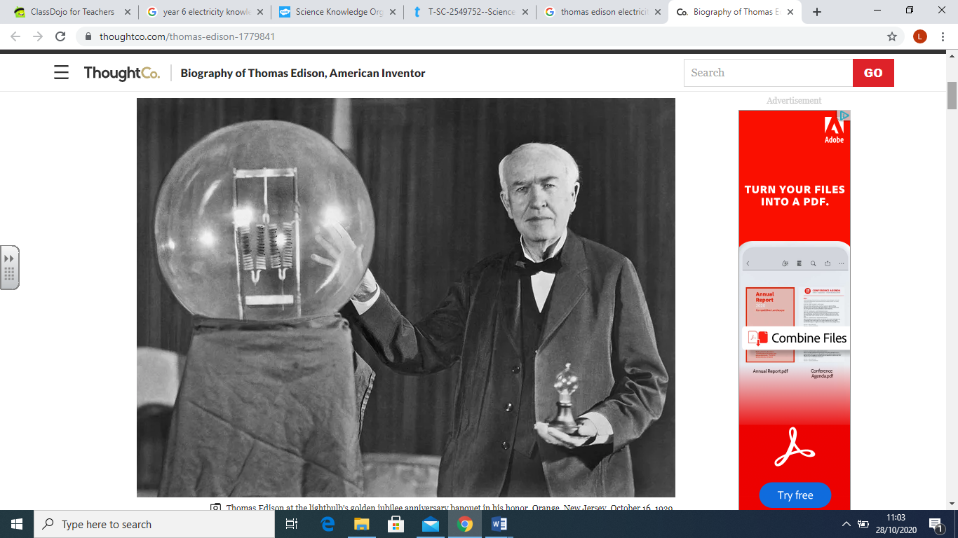

|  |  |
| --- | --- |
| **What Step On and Goldilocks words will I use?** | |
| **Spelling** | **Definition** |
| Ammeter | A device that measures the current. |
| Amps | How an electrical current is measured. |
| Appliance | A device for a particular task. |
| Battery | A portable power supply made up of more than one cell. |
| Bulb | An electrical component that gives off light. |
| Buzzer | An electrical device that makes a sound. |
| Cell | A single power source that is portable. |
| Circuit | An electrical loop with a power sources and at least one component. |
| Component | A part of an electrical circuit. |
| Current | A measure of how much electrical charge flows through a circuit. |
| Electricity | The flow of charge. |
| Electrons | Very small particles that travel around an electrical circuit. |
| Resistance | Something that slows the flow or current/electrical charge in a circuit. |
| Switch | Something that can break or complete an electrical circuit. |
| Symbol | A visual picture that stands for something else. |
| Voltage | The measure of how much energy is carried by electrical charge; the 'push' from the power source. |
| Wire | Something that connects parts of an electrical circuit. |

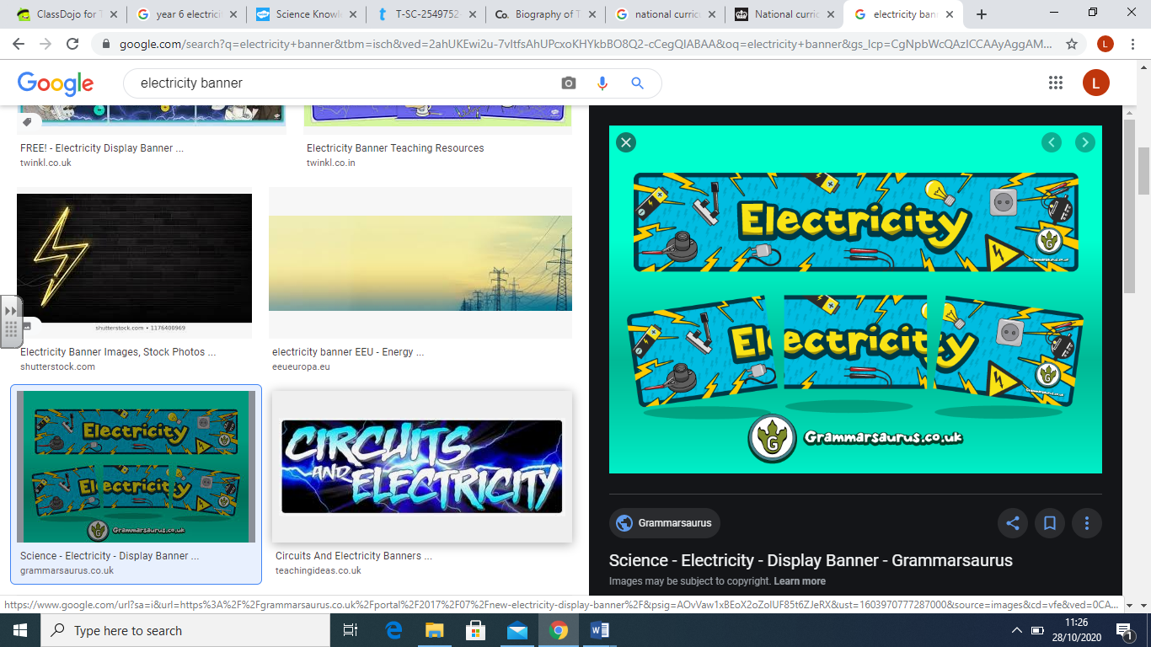

|  |
| --- |
| **Investigate!** |
| * Draw circuit diagrams with straight lines and using standard circuit symbols. * Design a results table with an appropriate number of columns and headings with units. * Identify the changed, measured and control variables in an enquiry to plan a method. |

|  |
| --- |
| **Enquiry Question** |
| What are the recognised symbols for electrical components?  How can I predict and present results for electrical circuits?  What is the link between the number of components and resistance?  What ways can we change voltage within an electrical circuit?  How does voltage affect bulb brightness?  How can I apply knowledge of circuit and components to a practical solution? |

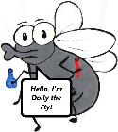

**What will I know by the end of the unit?**

|  |  |
| --- | --- |
| Children will… | |
| …associate the brightness of a lamp or the volume of a buzzer with the number and voltage of cells used in the circuit. Children will complete a series of investigations where they will understand that the higher the voltage, the brighter the bulb/louder the buzzer. They will do this by creating a simple series circuit using the correct apparatus. Before each investigation, the children will predict the outcome based on previous knowledge of electricity. | …use recognised symbols when representing a simple circuit in a diagram. Children will become familiar with the universal symbols within an electrical circuit and will be able to identify the representation accurately when completing their own investigations. |
| …compare and give reasons for variations in how components function, including the brightness of bulbs, the loudness of buzzers and the on/off position of switches. Children will further investigate simple series circuits by analysing the affect each component has within it. For example – does the length of the wire affect the brightness of the bulb? What happens if we have more than one bulb in the circuit without changing any other component? Children will learn that the outcome of a circuit will vary based on what is added or removed from it. |

|  |  |  |  |
| --- | --- | --- | --- |
| **F:\Learning bugs\Foundation Subjects\Dolly the Fly - Science.jpgLyng Primary School Knowledge Organiser** | | | |
| **Topic:** | **Science**  **Electricity** | Year 6 | Spring 2 |

|  |  |  |  |
| --- | --- | --- | --- |
| 1. What happens to the brightness of a bulb is we include more than one cell? | **S** | | **E** |
|  |  |  | |

|  |  |  |
| --- | --- | --- |
| 4. Correctly label the following symbols: | **S** | **E** |
|  |  |  |

|  |  |  |
| --- | --- | --- |
| 1. An ammeter measures: | **S** | **E** |
| 1. Resistance |  |  |
| 1. Current |  |  |
| 1. Sound |  |  |
| 1. Brightness |  |  |

|  |  |  |
| --- | --- | --- |
| 1. Draw a simple series circuit: | **S** | **E** |
|  |  |  |